FILE TAKEN TO CALCULATE THE WORD COUNT:

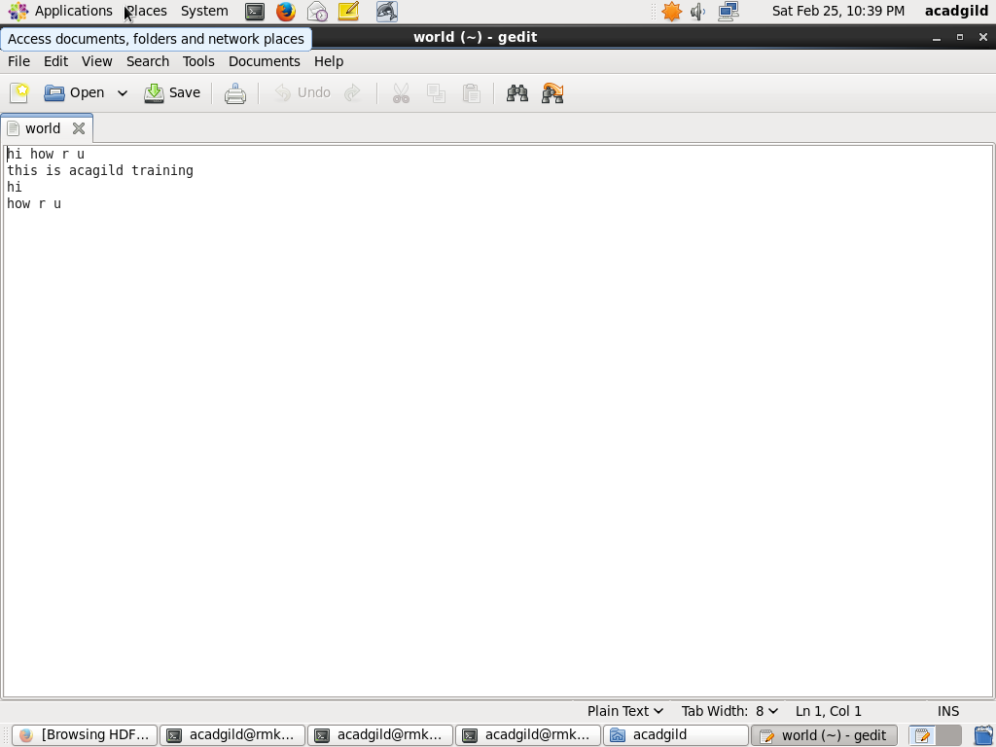

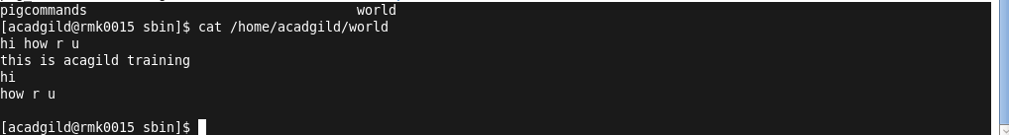

LOADING THE FILE INTO RELATION REL:

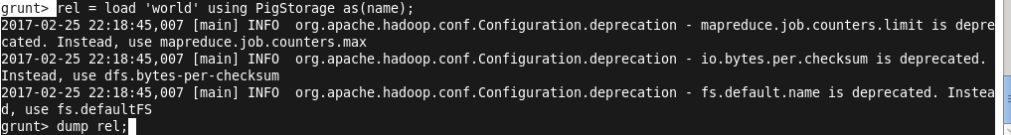

DUMP THE RELATION REL :

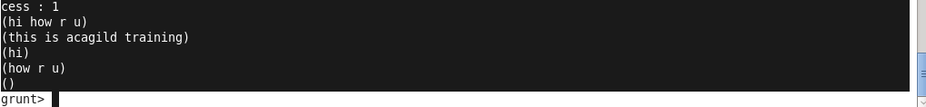

EXECUTION OF FLATTEN AND TOKENIZE COMMAND:

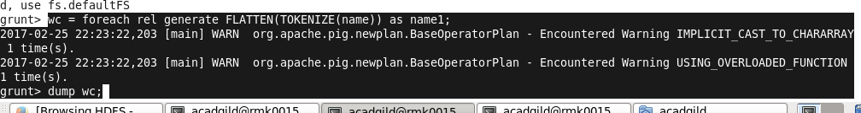

OUTPUT OF THE FLATTEN AND TOKENIZE COMMAND :

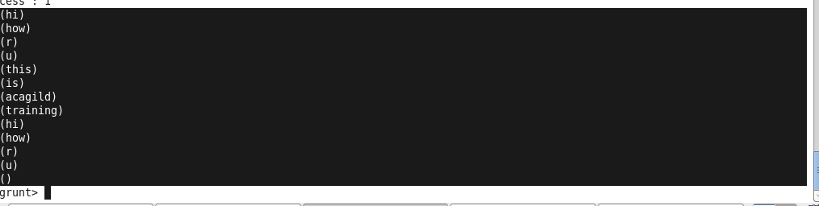

EXECUTION OF GROUP COMMAND:

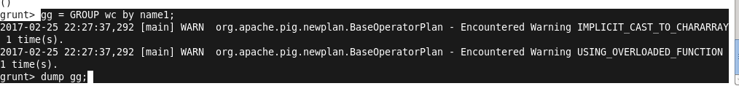

OUTPUT OF GROUP COMMAND:

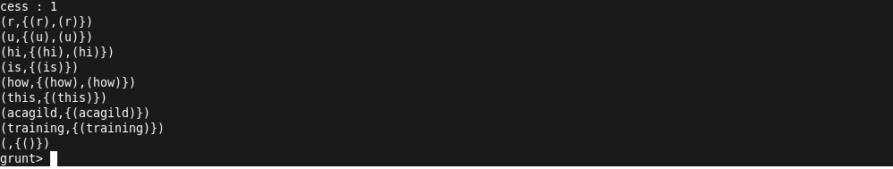

EXECUTION OF COUNT COMMAND TO FIND THE COUNT OF THE WORDS IN THE GIVEN FILE:

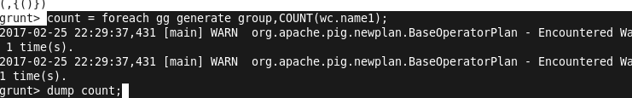

OUTPUT OF COUNT:

